HOTEL
MANAGEMENT
SYSTEM

INTRODUCTION

Our project title is Hotel Management System. We have tried our best to make the complicated process of Hotel Management System as simple as possible using structured & modular technique & menu-oriented interface. We have tried to design the project in such a way that user may not have any difficulty in using this package & further expansion is possible without much effort. Even though we cannot claim that this work to be entirely exhaustive, the main purpose of this project is to perform each employee’s activity in computerized way rather than manually which is time consuming.

We are confident that this software package can be readily used by non-programming personal avoiding human handled chance of error. This project is used by two types of users: -

i. Customers
ii. Administrator (management of the Hotel).

Administrator can maintain daily updates in the hotel records. Administrator must be an authorized user.

The main aim of the entire activity is to automate the process of day-to-day activities of hotel like room activities, admission of a new customer, assigning a room according to customer’s demand, checkout of a customer and releasing the room and finally compute the bill etc.

The limited time and resources have restricted us to incorporate, in this project, only a main activity that are performed in a HOTEL Management System, but utmost care has been taken to make the system efficient and user friendly.

“Hotel Management System” has been designed to computerize the following functions that are performed by the system:

- Add database of rooms in the hotel
- Guest Summary
- Search Room
- Search Customer
- Admission of New customer
- Room assigning related to customer’s need
- Bill
- Check-in customer
- Check-out customer
- Check availability of rooms
- Customer Details

OBJECTIVE

-  A computer-based management system is designed to handle all the primary information required.

- Separate database is maintained to handle all the details required for the correct statement calculation and generation.

- This project intends to introduce more user easiness in the various activities such as record updating, maintenance, and searching.

- The searching of record has been made quite simple as all the details of the customer can be obtained by simply keying in the identification of that customer.

- Similarly, record maintenance and updating can also be accomplished by using the identification of the customer with all the details being automatically generated. These details are also being promptly automatically updated in the master file thus keeping the record absolutely up to date.

- The entire information has maintained in the database or Files and whoever wants to retrieve can’t retrieve, only authorized user can retrieve the necessary information which can be easily accessible from the file.

FRONTEND

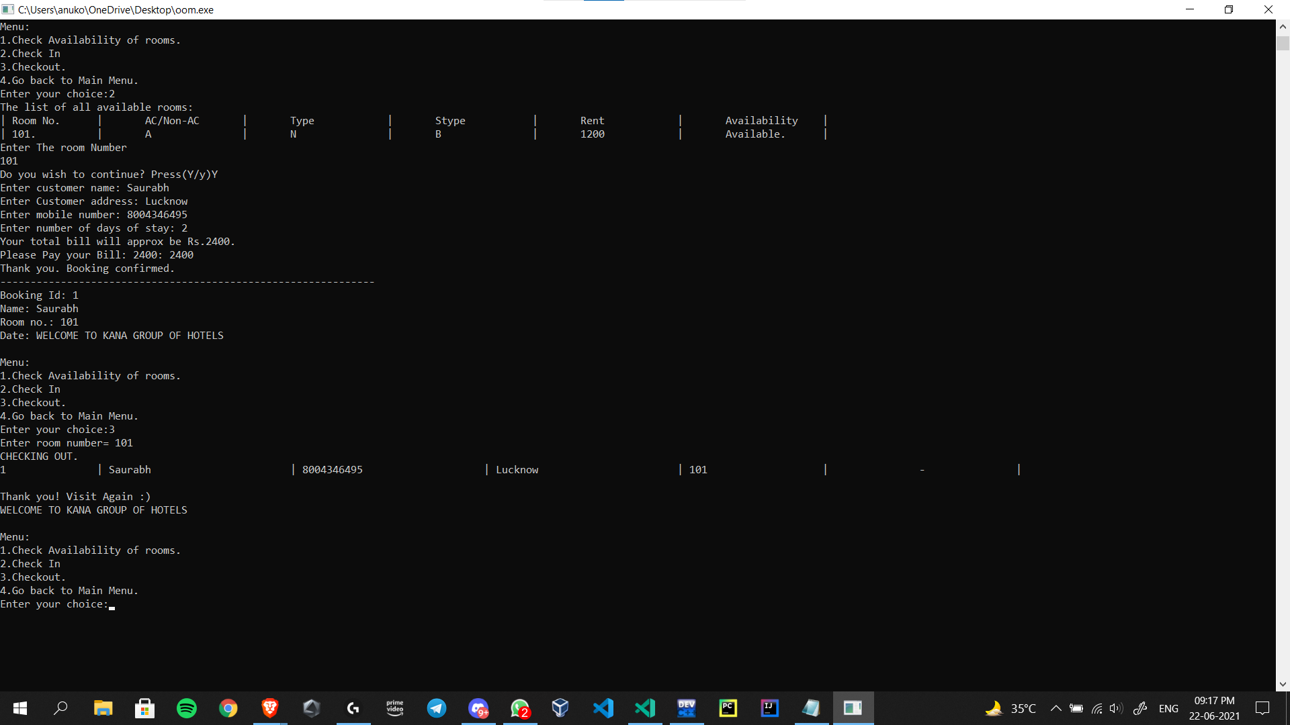
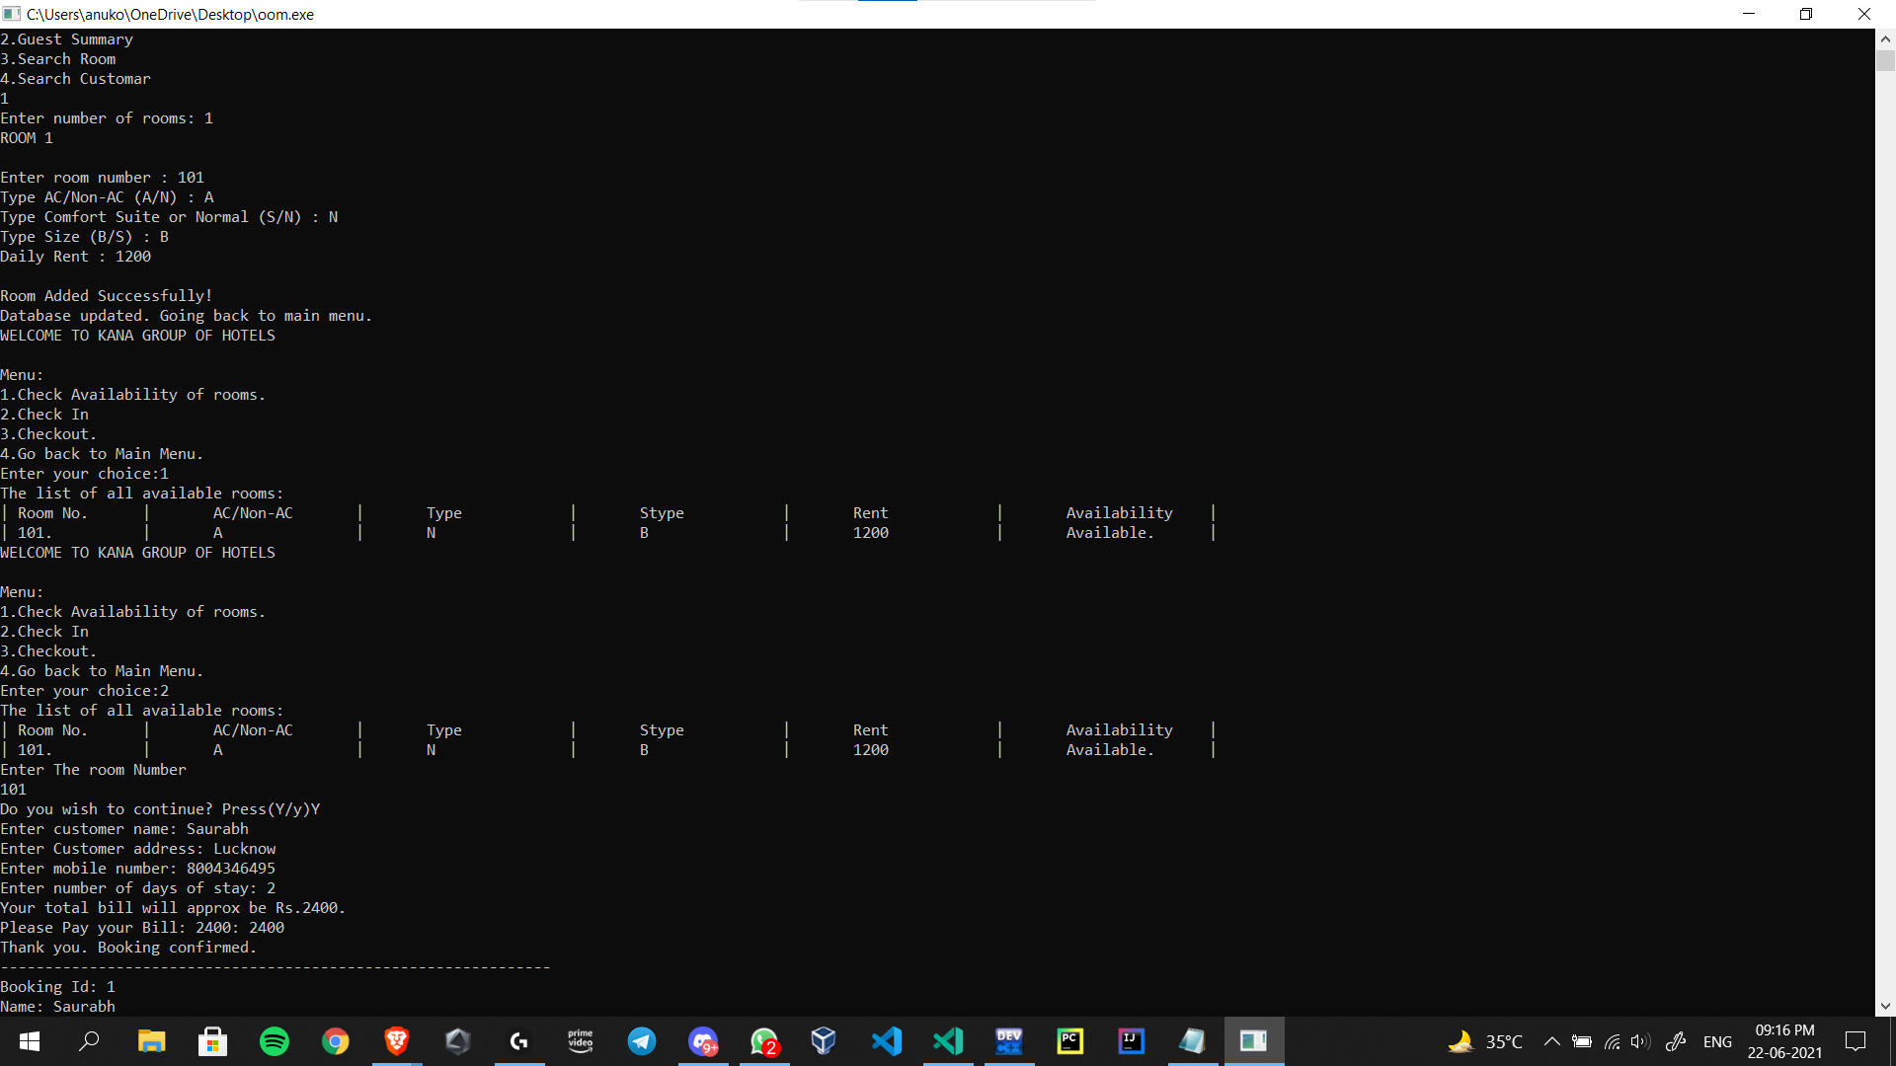

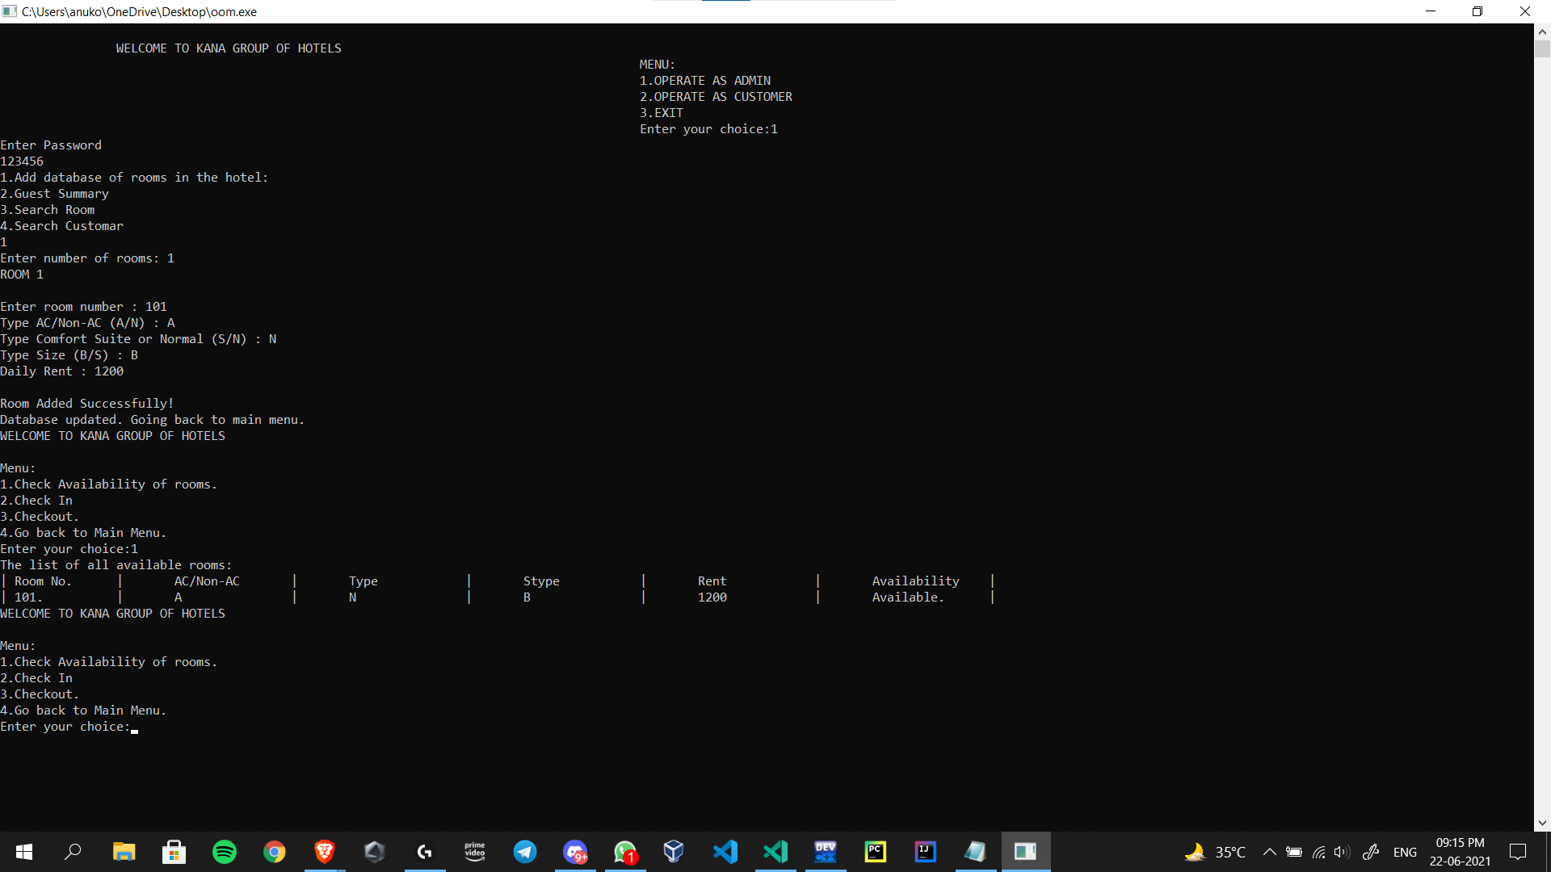
Class Diagram
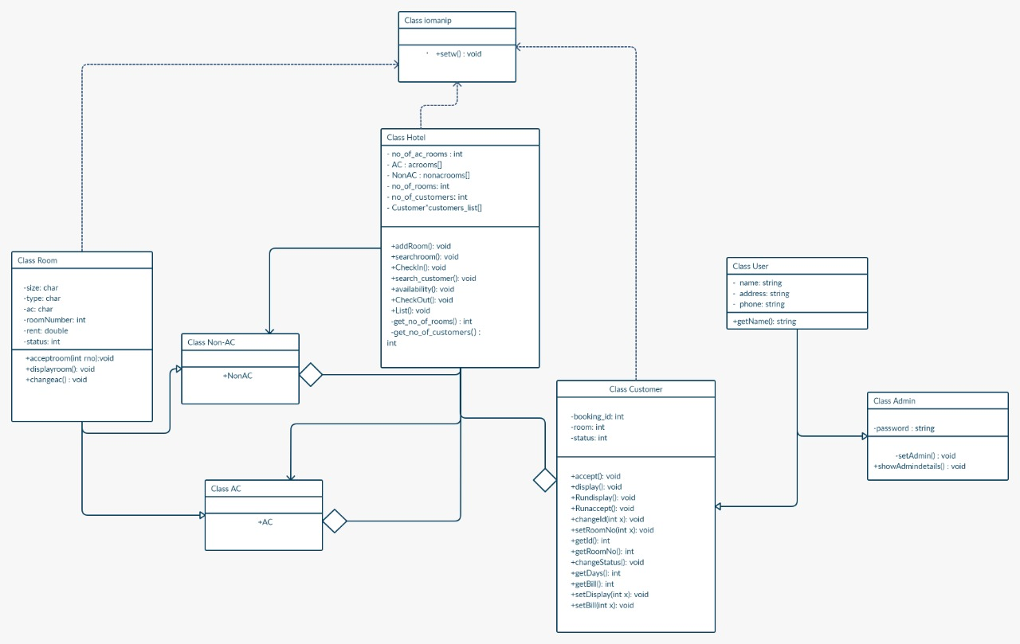

USE-CASE DIAGRAM

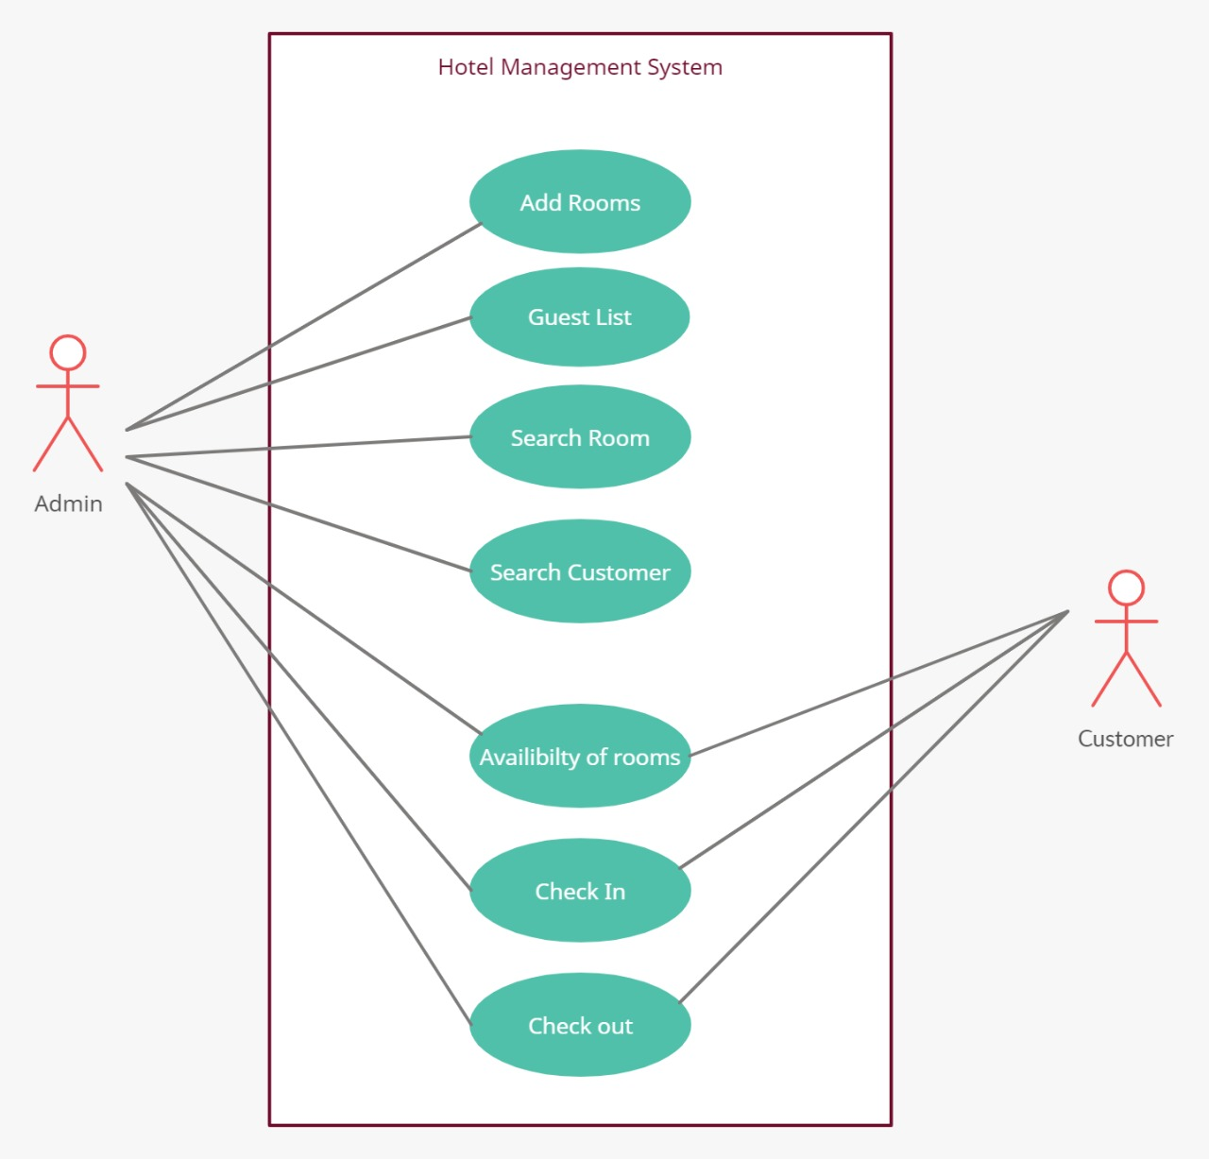

ACTIVITY DIAGRAM

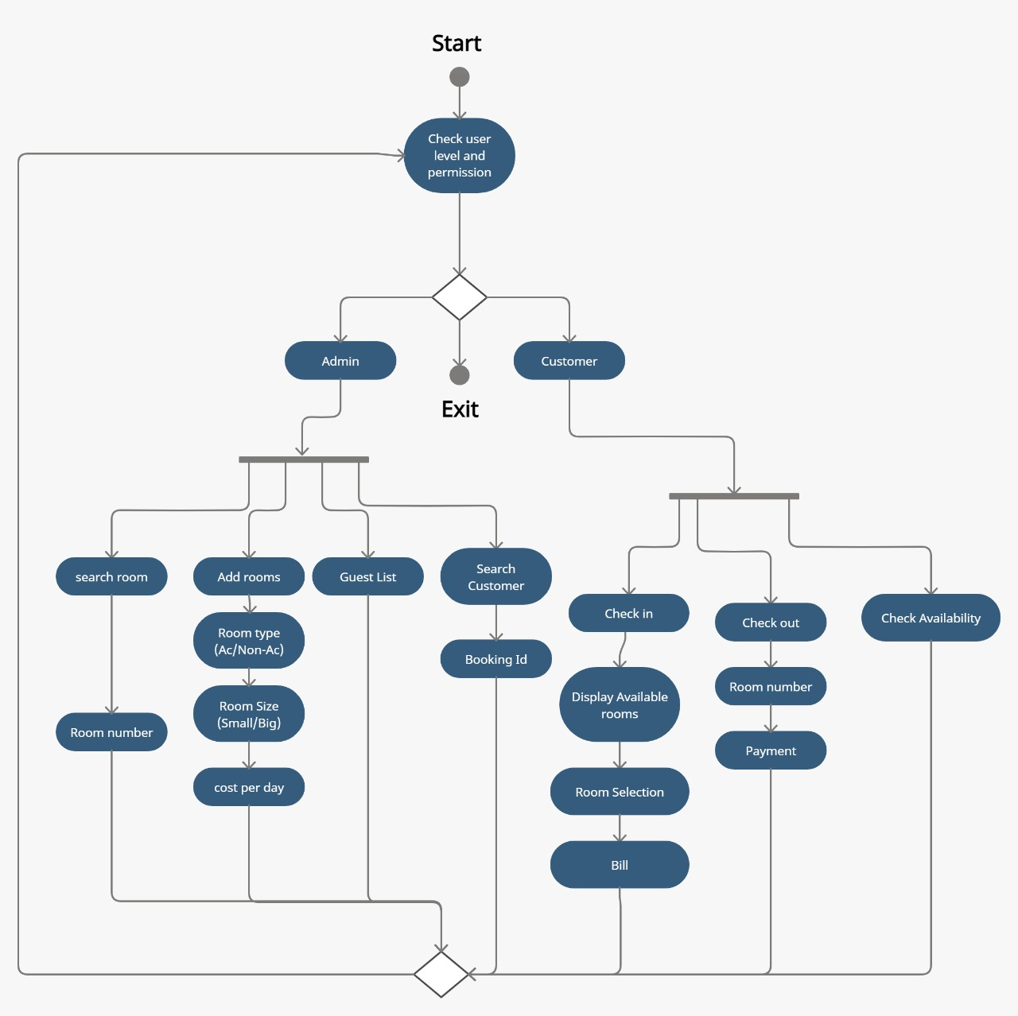

CONCLUSION

We have extensively understood the uses implementation of classes in the process of doing this project. We have also learnt and understood the concepts of inheritance, abstraction, structured programming, building algorithms, problem solving and most importantly teamwork.

